

**NAMA : TITO FEBRI ANGGARA**

**NIM : 210511126**

**KELAS : R3(C)**

PRAKTIKUM 4

MAHASISWAKKM

class mahasiswa_kkm:

def __init__(self,mahasiswa=None):

if mahasiswa is None:

self.mahasiswa = []

else:

self.mahasiswa = mahasiswa

def add_mahasiswa(self,mhs):

self.mahasiswa.append(mhs)

def daftar_mahasiswa(self):

for mhs in self.mahasiswa:

print(f'Nama\t\t: ',mhs.nama)

print(f'Jurusan\t\t: ',mhs.jurusan)

print(f'Semester\t: ',mhs.semester)

class Mhs:

def __init__(self,nama,jurusan,semester):

self.nama = nama

self.jurusan = jurusan

self.semester = semester

def get_nama(self):

return self.nama

def get_jurusan(self):

return self.jurusan

def get_semester(self):

return self.semester

class kkm:

def __init__(self,name_kkm,mahasiswa_kkm):

self.name_kkm = name_kkm

self.mahasiswa_kkm = mahasiswa_kkm

def tampil(self):

print(f'\nTempat KKM\t: {self.name_kkm}\n')

mhs1 = Mhs('titofebrianggara', 'Teknik Informatika', 4)

mhs2 = Mhs('maolana', 'Teknik Informatika', 4)

mhs3 = Mhs('alimabrur', 'Teknik Informatika', 4)

mhs_kkm = mahasiswa_kkm([mhs1, mhs2, mhs3])

Kkm = kkm('Busan, South Korea', mhs_kkm)

Kkm.mahasiswa_kkm.mahasiswa

Kkm.tampil()

Kkm.mahasiswa_kkm.daftar_mahasiswa()

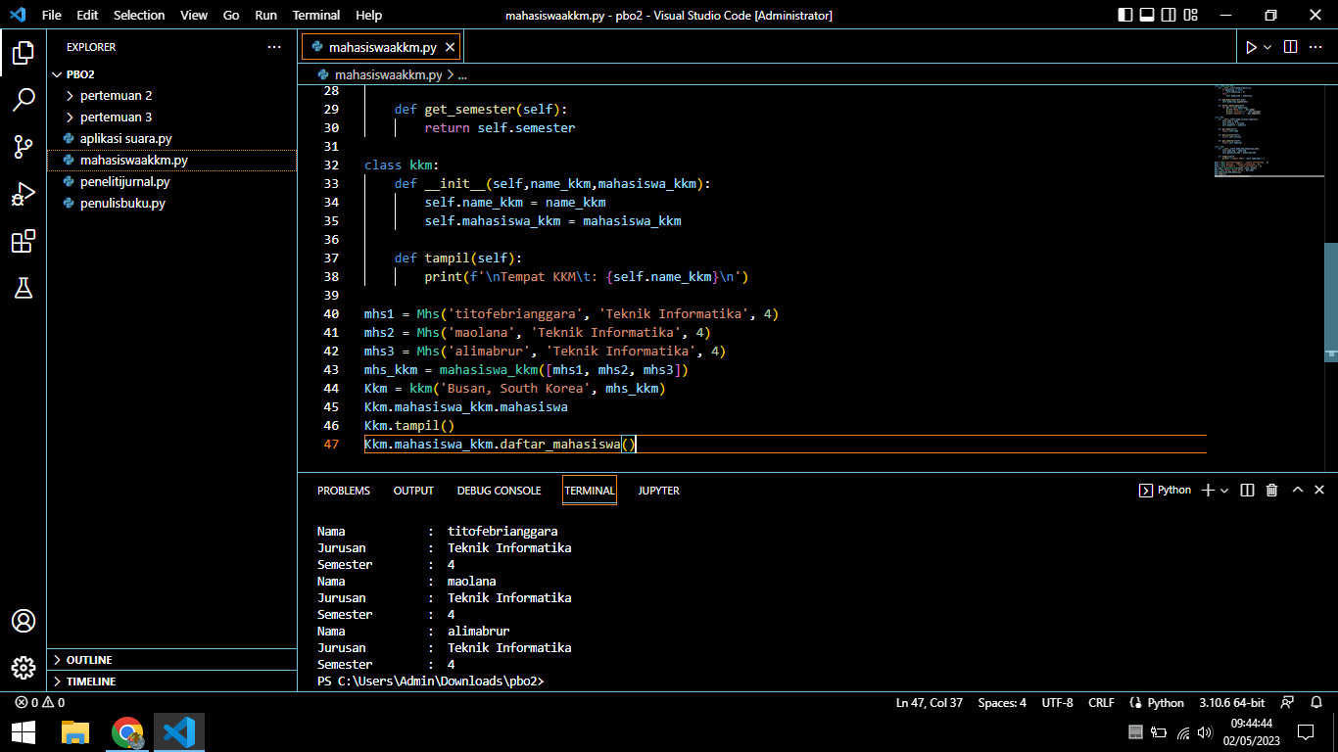

PENELITI JURNAL

class Jurnal:

def __init__(self,title,date):

self.title = title

self.date = date

class peneliti:

def __init__(self,nama,jurnal):

self.nama = nama

self.jurnal = jurnal

def daftar_jurnal(self):

print(f'\nPeneliti\t: {self.nama}\n')

for jurnal in self.jurnal:

print(f'Judul\t\t: ',jurnal.title)

print(f'Published\t: {jurnal.date}')

jurnal1 = Jurnal('The Paradox of Indonesian Digital Economy Development', 2020)

jurnal2 = Jurnal('Towards Data Sovereignty in Cyberspace', 2015)

peneliti1 = peneliti('AS Sastrosubroto', [jurnal1, jurnal2])

jurnal3 = Jurnal('A Century of Trends in Adult Human Height', 2016)

jurnal4 = Jurnal('Repositioning of The Global Epicentre of Non-optimal Cholesterol', 2020)

peneliti2 = peneliti('IS Widyahening', [jurnal3, jurnal4])

peneliti1.daftar_jurnal()

peneliti2.daftar_jurnal()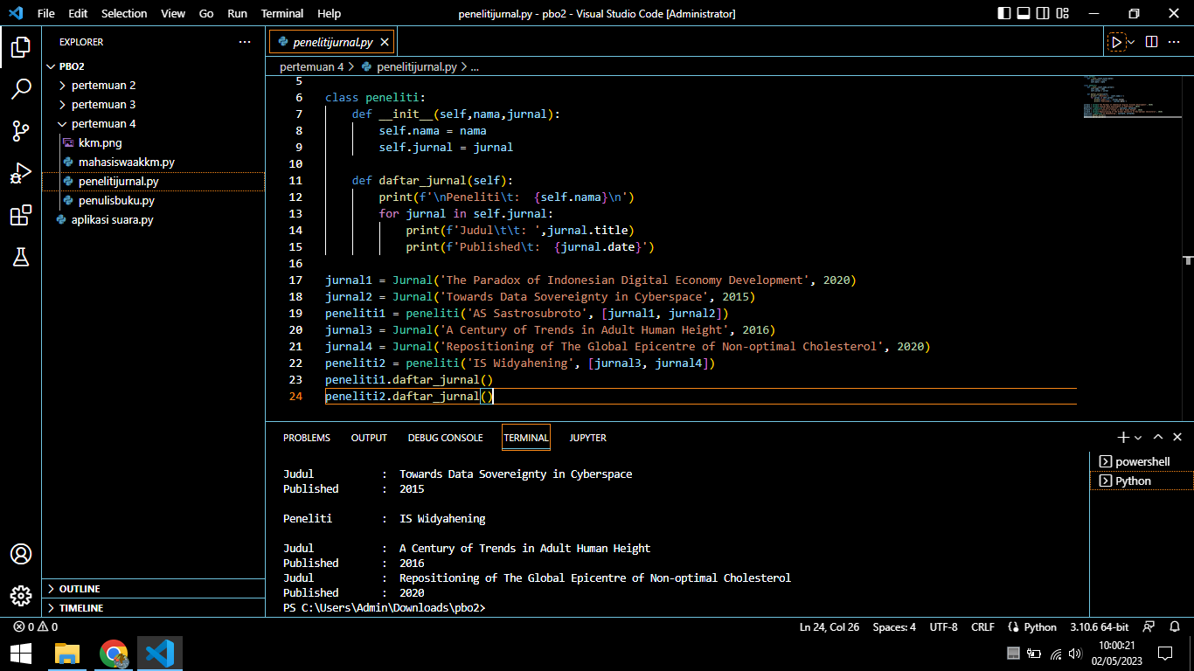

PENULIS BUKU

class Penulis:

def __init__(self,nama):

self.nama = nama

self.inventory = Inventory()

def tampil(self):

print(f'\nPenulis\t\t: {self.nama}\n')

class Buku:

def __init__(self,judul,publish,penerbit):

self.judul = judul

self.publish = publish

self.penerbit = penerbit

def get_judul(self):

return self.judul

def get_publish(self):

return self.publish

def get_penerbit(self):

return self.penerbit

class Inventory:

def __init__(self):

self.books = []

def add_buku(self,buku):

self.books.append(buku)

def daftar_buku(self):

for buku in self.books:

print(f'Judul\t\t: ',buku.judul)

print(f'Terbit\t\t: ',buku.publish)

print(f'Penerbit\t: ',buku.penerbit)

penulis1 = Penulis('Tere Liye')

bumi = Buku('Bumi', 'Jakarta, 2014', 'Gramedia Pustaka Utama')

bulan = Buku('Bulan', 'Jakarta, 2015', 'Gramedia Pustaka Utama')

matahari = Buku('Matahari', 'Jakarta, 2016', 'Gramedia Pustaka Utama')

bintang = Buku('Bintang', 'Jakarta, 2017', 'Gramedia Pustaka Utama\n')

penulis1.inventory.add_buku(bumi)

penulis1.inventory.add_buku(bulan)

penulis1.inventory.add_buku(matahari)

penulis1.inventory.add_buku(bintang)

penulis1.inventory.books

penulis1.tampil()

penulis1.inventory.daftar_buku()